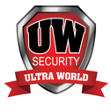

**ULTRA WORLD**

SECURITY SERVICES

**Company Profile**



**Contents**

**Introduction………………………………………………………………………………………1**

**Executive Summary.............................................................................2 Mission...............................................................................................2**

**Vision..................................................................................................2**

**Competitive Advantage.......................................................................3**

**Service............................................................................................ 3/4**

**Service History................................................................................... 5**

**OH&S Policy............................................ ...........................................6**

**Management Profile...........................................................................7**

**Our Prices………………………………………………………………………………………….8**

**Contacts..............................................................................................9**



**………………………………………………, 03.04.2023.**

**……………………………………………..,**

**……………………………………………….,**

**Dear Madam/ Sir,**

Our company has the pleasure to submit to you our business and skills profile. Ultra World Security and Systems Limited (UW security) has been working in the region, providing security services.

Our experiences and professional methods of security are applied for outstanding services provided to our customers.

We have a network of Experience Managers and supervisors who ensures that our Staff/Guards are well trained as well as well motivated to provide the expected level of service and even surpass our customer’s expectation. We work closely with the Local Security Administration to ensure that our customers and their properties are well protected.

We have attached our company profile for your further perusal, and we look forward to working with your esteemed company.

Yours faithfully,

FOR: ULTRA WORLD SECURITY LIMITED

GLADYS C. SOI,

CHIEF EXECUTIVE OFFICER



**Executive Summary**

Ultra World Security Systems Ltd (UWS) was established in 2014 to provide high quality security solutions. Since then, UWS has established itself as one of Kenya’s leading security providers. Since it commences its operation UWS has proactively kept pace with the ever changing security industry by offering superior coverage and service for all types of business. Through tailor-made integrated solutions. UWS has earn a reputation for excellence and customer service. Truth, honour and safety are the core values which govern UWS services and operations. UWS aims to exceed its client’s expectations by understanding their requirements and customizing security solutions to best suit their needs.

At Ultra World Security, we care about our customers and their business. We focus on detail that will bring your company to the forefront in your industry. We will provide that first impression and customer service that will set your company ahead of your competition.

Call us at Ultra World Security and let us show you how we make the difference in the service we provide.

**Mission**

“To be a leader in providing protection, security and investigation services in Kenya. To deliver high quality security solutions at a competitive rate”.

**Vision**

Our vision is to be preferred customer focused firm in providing world-class state of the art security solutions in East and Central Africa region as well as maintaining a highly skilled, professional and people friendly staff.



**Competitive Advantage**

* Rapid response times
* Competitive flat rates
* 24/7 Support
* Reliable and experienced Security Officers

**Services**

**Static Guard Services**

* Monitoring Centre security
* Customer services
* Multi-story site security
* Special event security
* Site security
* Site patrols
* Bodyguard
* Gatehouse
* Dog Services (K9 Unit)

**Corporate Services**

* Personal protection for executives and individuals
* Office and factory area protection
* Corporate security personnel
* Theft and stock loss
* learning Institutions



**Security Consultancy**

* Security Risk Assessment
* Security Auditing
* Security surveys
* Security Specialized Trainings

**Private Investigation services**

* Surveillance
* Fraud and Stealing

**Service History**

UWS had provided security solutions to the following clients:

* Ridgeways Baptist Church- Nairobi County
* Gathu Holdings – Nairobi County
* Jerusalem Motors ltd - Nairobi County
* Votex Limited - Nairobi County
* Blue Enamone Limited- Nairobi County
* Kasarini Secondary School – Kiambu County
* Kericho High Secondary School – Kericho County
* Tengecha Boys’ High Secondary School – Kericho County
* Kaplong Girls’ High Secondary School – Bomet County
* Rabdiya Construction Limited – Nairobi County.
* Empower Hope – Nairobi
* Imarisha Sacco – Nairobi, Nakuru and Kericho

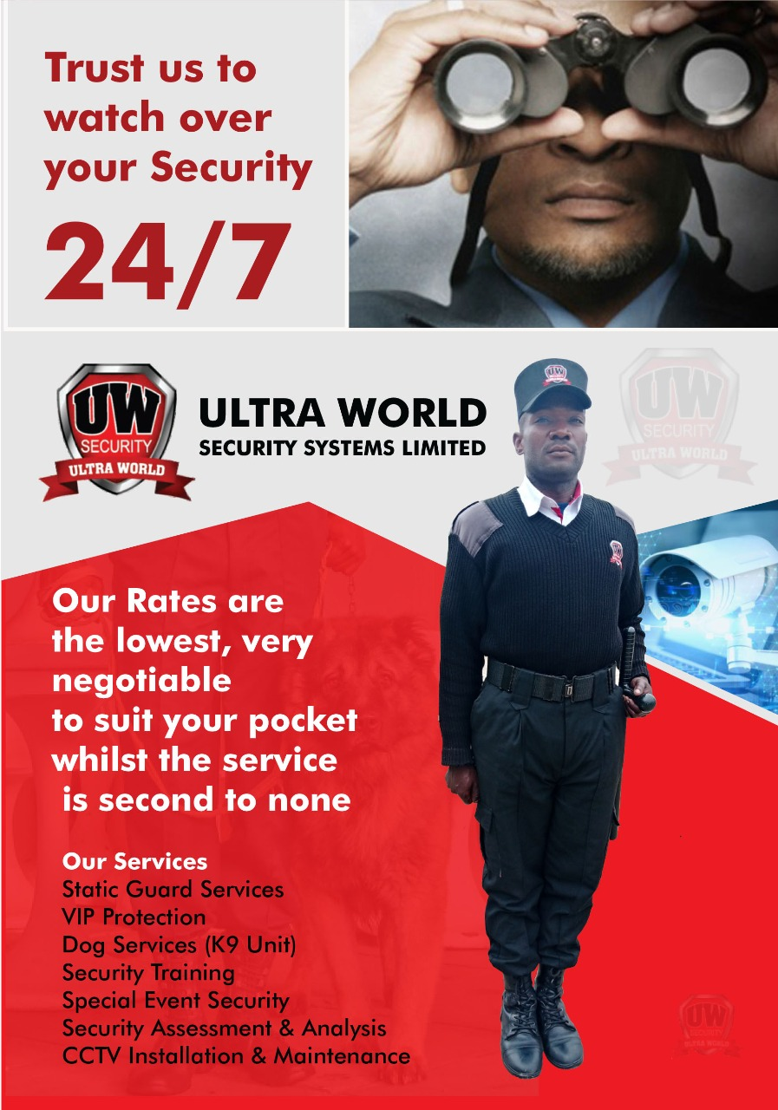

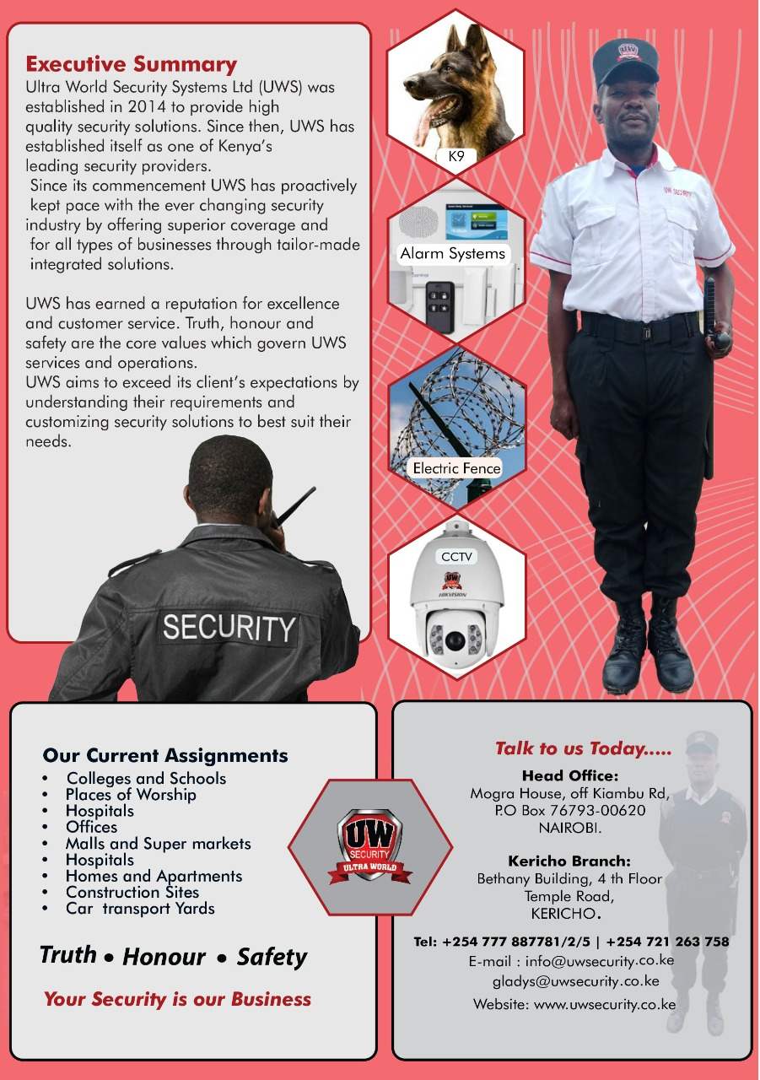



**ALARMS**

For decades, security systems have kept businesses & homes and their occupants safe and secure. Ultra World Security’s sophisticated alarms employ high-tech sensors to identify broken locks, opening doors and windows, unexpected movement, breaking glass and other intrusion events.

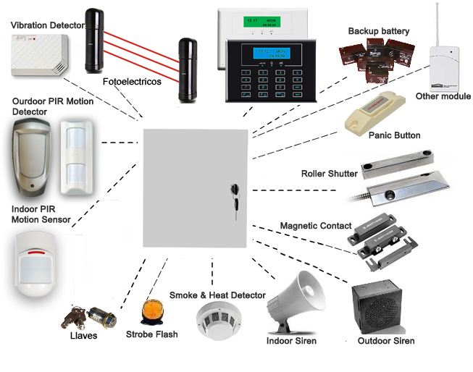



**CLOSED CIRCUIT TELEVISION (CCTV)**

CCTV is a very powerful tool in the fi ght against crime. Not only does CCTV provide a fantastic visual deterrent – footage can be used to provide evidence against anti-social behavior, theft, vandalism and burglary – saving you thousands in the long run.

• CCTV helps to deter thieves

• View remote locations, including multiple locations at once

• Safely monitor premises from a control room

• Provide CCTV evidence to Police to secure a prosecution

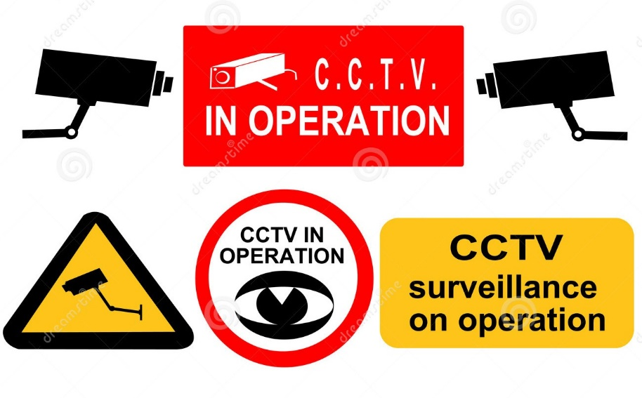

At Ultra World Security, we have a wide variety of camera types that ensures you get what will fi t your environment and budget; day and night cameras, small and very small cameras, short range and long range view cameras. CCTV cameras can also be integrated with other security systems like access control where the camera is triggered by the access control system etc.



**DOG SERVICES**

The quality that is most associated with dogs is their extraordinary sense of smell, proving increasingly useful to the security industry and that it is one of the canine capabilities that UWS is putting to good use throughout Kenya.

The risk of terrorist attacks against high-profile events and businesses is one of the threats that have led to an increase in canine assistance; UWS make use of their special talents.

Whether the requirement is for general purpose dog-handler teams is to conduct perimeter patrols, search for explosives at a conference, or conduct a passive drugs search of entrants to a place of work or a high density event, UWS canine handlers and their four-legged friends are the perfect partnership to investigate all manner of suspicious or criminal activity.

**Static Security Dogs**

The static dog units are an extremely high visual deterrent and can cut down on the man power needed in static guarding alone. Our Ultra world security dogs are trained in article tracking, building searches, find and locate and handler protection, making us the unbeatable team on any assignment.

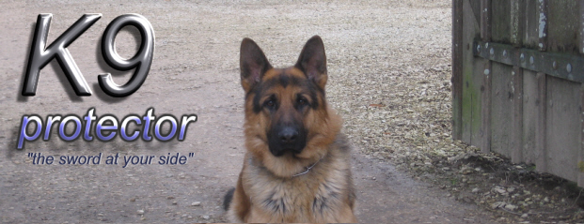

Our Professional Management team and supervisors ensure that Security Patrol / Guard Dogs and handler teams are being kept up-to-date with regular continuous training. Guard Dogs are a proven asset in the reduction of theft, criminal damage and violent behavior. It is commonly accepted that one Security Patrol Dog and Handler team can be as effective as five static security officers, due to the canine’s excellent olfactory system.

We are members of the following organizations:

• KEPSA



**UWS OH&S Policy**

UWS commits to provide a safe and healthy environment for all employees. This is achieved by fully integrating health and safety into all its operations and activities, continual improvement and requiring leadership in safety.

UWS strive to achieve a safety management system, to implement systematic identification assessment of risk, and control measures to mitigate identified risks. Effective communication and consultation changes form a fundamental part of this management process, encouraging innovative means of reducing risk in the work environment. Training and information will be provided to assist staff to identify health and safety hazards, leading to safe work practices within the company.

UWS will:

* Provide and maintain a safe work environment for all employees.
* Abide by all statutory requirements and relevant codes of practice as the minimum security standard.
* Ensure that all employees are provided with adequate instructions for safe working procedures, and will inform them of any hazard to their health and safety.
* Ensure to minimize hazards within the work place in order to prevent accidents from occurring.
* Promote and develop safety awareness throughout the Company.



**Management Profile**

**CHIEF EXECUTIVE OFFICER**

**Gladys Soi joined the Security Industry in 2010 as a business development director in a leading security firm. She has a wealth of experience in Security Management for over 10 years.**

**She has been with Ultra World security and Systems from its inception, as a founder and has continue to grow the business with other company employees whom she leads.**

**Prior to UWS, Gladys has senior position at Intercity Secure Homes and a management position at Standard Chartered Bank.**

**She has a degree in BA Economics and Sociology and MBA in marketing.**

Photo

SDWEEEEEEEE

**Edison Kosonei joined the security industry in 1998 as a Police Constable. In 2003 he moved to commercial security as an instructor in one of the leading security provider in East and Central Africa. With over 20 years of experience within the security industry Edison has acquired extensive knowledge of all areas of security operations and trainings having served in South Sudan, DRC, Tanzania and Kenya in various capacities. Since then Edison has built a reputation in providing high-level security management systems, professional advice and support to companies, diplomatic corps and NGO’s. In addition to addressing security solutions Edison also provides consultation in areas such as security assessments and audit, threat assessment risk analysis and mitigation. Previously attached to delegation of EU and USAID in South Sudan, PLAN international, Dusit 14 Riverside and Braeburn group of schools. Edison holds a SAC DIP & CSMP Security management.**

**HEAD OF OPERATIONS & TRAINING**

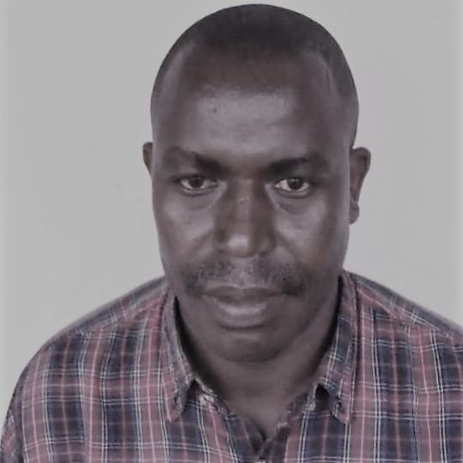





**Find quotation for guarding, supervision and dog patrols services as well as other associated security services on all your establishments countrywide.**

**GUARDING**

**Day/Night guard 12 Hours shift Kshs. 18,000.00 Plus VAT per month**

**Dog and Dog Handler 12 hour shift Kshs. 20,000.00 Plus VAT per month**

**We hope that you will find our proposal viable and consider us as we look forward to a mutual working relation.**

For more information, email us at: [**info@uwsecurity.co.ke/gladys@uwsecurity.co.ke**](mailto:info@uwsecurity.co.ke/gladys@uwsecurity.co.ke)

Yours faithfully,

**FOR: ULTRA WORLD SECURITY LIMITED**

**GLADYS C SOI**

**CHIEF EXECUTIVE OFFICER.**



**CONTACTS**

**Chief Executive Officer**

**M/s. Gladys C. Soi**

**Mob: +254 721 263 758**

**E-mail: gladys@uwsecurity.co.ke**

**Head of Operations & Training**

**Mr. Edison K. Kosonei**

**Mob: +254 777 887783**

**E-mail:** [**kosonei@uwsecurity.co.ke/**](mailto:kosonei@uwsecurity.co.ke/) **operation@uwsecurity.co.ke**

**Office Manager Nairobi Branch**

**Mr. Kelvin Wafula**

**Mob: +254 777 887782**

**E-mail: info@uwsecurity.co.ke**

**Office Manager Kericho Branch,**

**Mr. Joel Rono**

**Mob: +254 777 887785**

**E – Mail: sales@uwsecurity.co.ke**

**E-mail: sales@uwsecurity.co.ke**

**Head Office:**

**Mogra House, off Kiambu Rd,**

**P.O Box 76793-00620**

**NAIROBI.**

**Kericho Branch:**

**Kontainer City,**

**Kericho – Nakuru Highway,**

**KERICHO.**

**Tel: 0777 887781/2/5**

**Mob: +254 721 263 758**

**E-mail:** [**info@uwsecurity.co.ke**](mailto:info@uwsecurity.co.ke)

**: gladys@uwsecurity.co.ke**

**Website:** [**www.uwsecurity.co.ke**](http://www.uwsecurity.co.ke)